REGISTRATION FORM: 2021-2022 AREA 3 MEETING
ZONTA INTERNATIONAL, DISTRICT 11
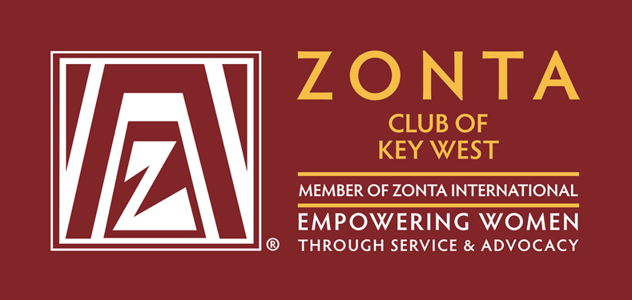  Date: Saturday, May 21, 2022  Time: 9:00am | Registration is from  8:30-9:00am  Sat. May 21, 2022  Meeting is from  9:00am – 3:00pm | Meeting Place:  DoubleTree by Hilton  Mangrove Room | Hotel Name: DoubleTree by Hilton  Hotel Address: 3990 South Roosevelt, Key West, FL 33040  Telephone: 1-305-293-1818  Contact: Dianne Forrest  Website: www.doubletreekeywest.com  Your group code is ZCM
Hosted by: | Zonta Club of Key West

REGISTRATION INFORMATION
Name
Zonta Club of
Club Officer? |  |  |  | President |  |  |  |  | Treasurer |  |  |  |  |  | President Elect/Vice President |  |  |  | Secretary
Current or Past-District or ZI Officer? [Position held]
Check if you are a first timer? |  |  |  |  |  |  |  |  |  | Guest of?
Address
City, State, Zip code
Your Leadership Personality Style: |  |  |  |  |  | ORANGE |  |  |  |  | GREEN |  |  |  |  |  | BLUE |  |  |  | GOLD
Telephone |  |  |  |  |  |  |  |  |  |  |  | (day) |  |  |  |  |  |  |  | (evening)
Email address

Amount enclosed $ |  | Meeting Registration Fee is $75.00 by 04/30/22 $95 after 04/30/22

HOTEL:
Will you be staying at the Doubletree by Hilton, Key West? | Yes |  | No
If yes, you must make your own reservations by contacting the hotel, information above. MAKE SURE TO reference our Zonta group code is ZCM for Fri. May 20, 2022 & Sat., May 21, 2022. The special Zonta room rate is $349.00
No Valet parking available. Guest overnight parking is complimentary.

FRIDAY NIGHT DINNER
Would you like to meet other Zontians for Dinner at a local restaurant Friday evening | Yes |  | No
If yes, please be in the lobby of the Hotel at 6:00 pm on Friday, May 20, 2022. We will be going to Siboney Restaurant. 5501 5th Street, Stock Island, Fl. 33040 – Dinner Cost is $27.00 incl. Tax & Tip.
Come and enjoy good fellowship with friends, old and new!

FEE PAYMENT
Issue your check to: Zonta Club of Key West
Send this registration form and payment of $75.00 by April 30, 2022 to: Jerilyn Barack
Zonta Club of Key West
3075 Flagler Avenue, Unit 13
Key West, FL 33040
Contact: Jerilyn Barack:
For additional information contact:
Cell # - 305-509-2000
E-Mail : jerilynbarack@gmail.com
Maria Crowley: mi.crowley@yahoo.com

